APPENDIX E

School and Childcare Facility Certification Form

This appendix provides the certification form that should be submitted by July 1st each year certifying information for the previous year.

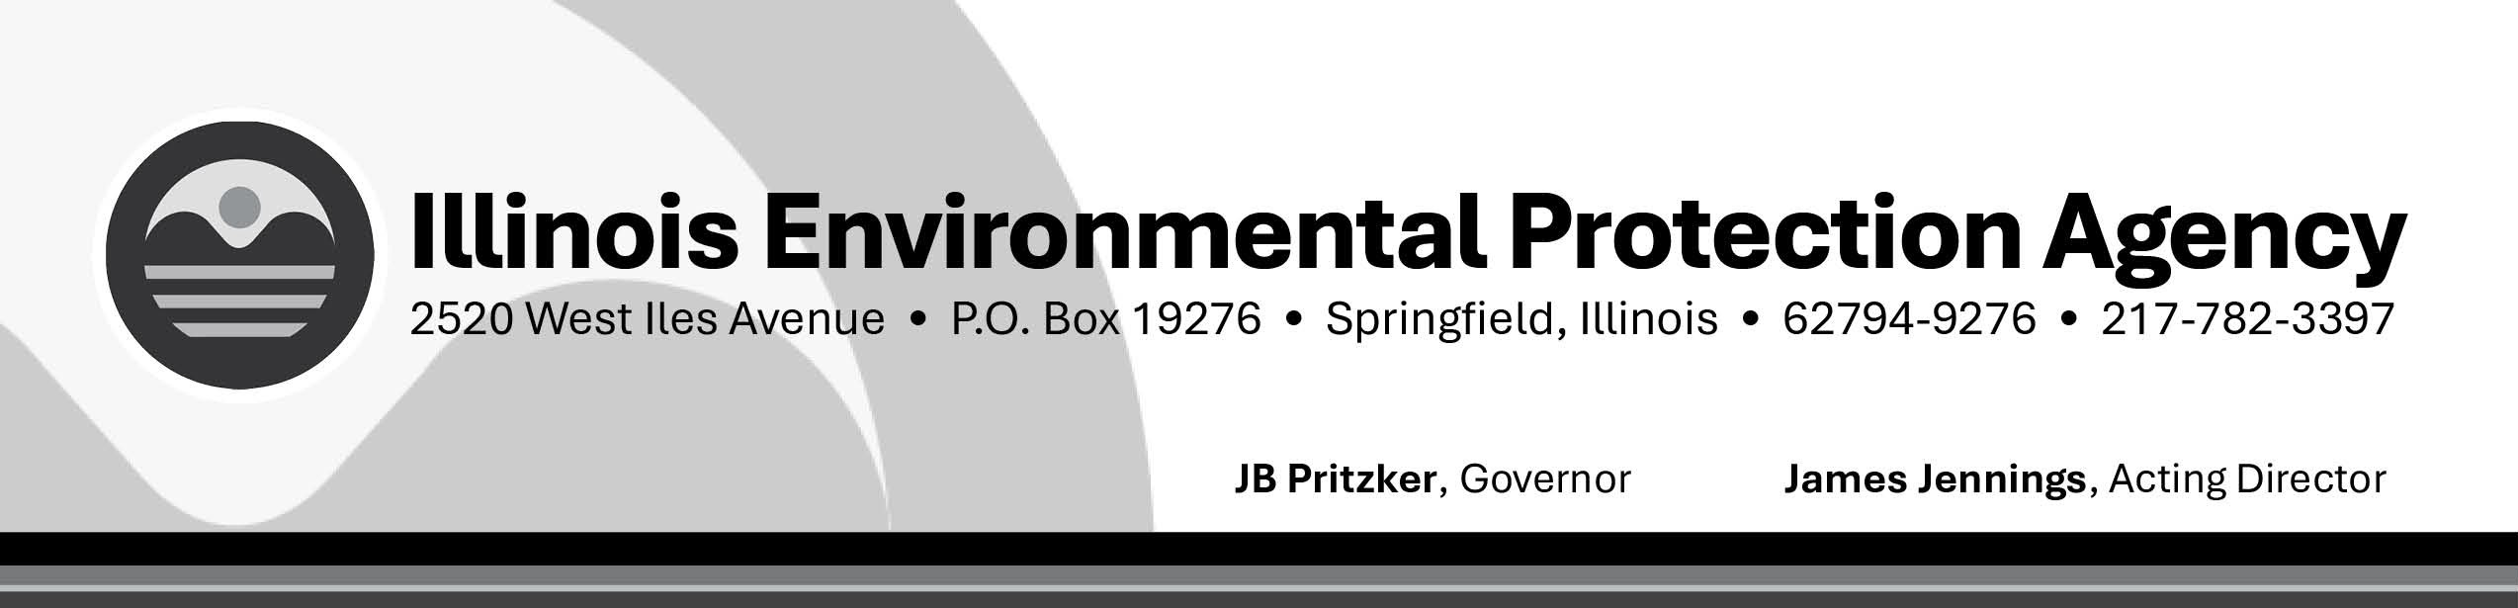

School and Child care Public Education and Sampling Reporting Form

After your CWS has completed the Lead Sampling and Public education distribution to schools and child care facilities please complete all the information below and return to: Lead/Copper Coordinator, at EPA.Leadandcopper@illinois.gov or Illinois EPA / BOW / CAS #19, 2520 West Iles Avenue, P.O. Box 19276, Springfield, Illinois 62794-9276. Be sure to include a copy of your PE materials along with this form. If you have questions when assembling/delivering your PE, please call the Lead/Copper Coordinator at 217-524-4655.
PWS Name: PWS No.
Contact Person: Phone:

Today's Date:

Distribution of our PE program was completed on:

Please initial all that are applicable
Initials |  | Date  completed
 | A good faith effort was made to identify all schools and child care facilities in the distribution system.
 | Information about health risks from lead in drinking water was delivered to all schools and child care facilities served.
 | At least 20% of all schools and 20% of all child care facilities were sampled for the calendar year.
 | Sampling results were provided to all schools and child care facilities sampled.

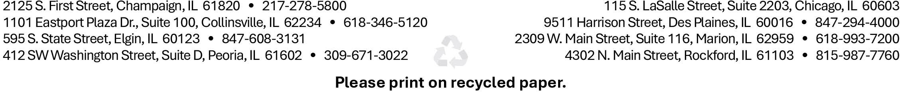

Please enter the following information for the CWS:
- Total number of Schools served by the CWS.
- Total number of child care facilities served by the CWS.
- Total number of schools and child care facilities that refused sampling this calendar year.

  - First type of outreach attempted.
  - Second type of outreach attempted.
  - Any additional outreach.
Signature of Owner, Administrative Contact, or Official Custodian
I hereby certify that our annual school and child care facility sampling was completed and lead public education was distributed to all schools and child care facilities served by the CWS.

Signature Date

Printed Name Title

